

**Buckeye Local Schools 23/24 Calendar**

<https://www.buckeyeschools.info/documents/2023-24-Master-Calendar.pdf>

**An Electronic Copy of: "A Guide to Parent Rights in Special Education" is available at:**  <http://education.ohio.gov/Topics/Special-Education/A-Guide-to-Parent-Rights-in-Special-Education>

**Information about Jon Peterson, Autism and other Scholarship Programs are available at:** <http://education.ohio.gov/Topics/Other-Resources/Scholarships>

**SameGoal Instruction**

<https://www.youtube.com/watch?v=TrMpcWpLjq0>

<https://samegoal.com/iep/g/support/online-guides/user-guide/guardian-shared-documents>

**Resources for Families of Children with Disabilities**

<https://www.parentcenterhub.org/>

**Contact Information**

**Director of Pupil and Personnel:** Danyel Ryan [d.ryan@buckeyeschools.info](mailto:d.ryan@buckeyeschools.info)

440-990-3135

**Special Education Supervisor**: Alissa Zappitelli [a.zappitelli@buckeyeschools.info](mailto:a.zappitelli@buckeyeschools.info)

440-998-4411

**Ridgeview Elementary**: 440-997-7321

Principal: Tracy Deluca [t.deluca@buckeyeschools.info](mailto:t.deluca@buckeyeschools.info)

K-3 Intervention Specialist: Elaine Applebee [e.applebee@buckeyeschools.info](mailto:e.applebee@buckeyeschools.info)

4-5 Intervention Specialist: Maria Dibenedetto [m.dibenedetto@buckeyeschools.info](mailto:m.dibenedetto@buckeyeschools.info)

**Kingsville Elementary:** 440-224-0281

Principal: Timothy Neal [t.neal@buckeyeschools.info](mailto:t.neal@buckeyeschools.info)

K-3 Intervention Specialist: Steven Urcheck [s.urcheck@buckeyeschools.info](mailto:s.urcheck@buckeyeschools.info)

4-5 Intervention Specialist: Peyton Longden [p.longden@buckeyeschools.info](mailto:p.longden@buckeyeschools.info)

K-4 Cross Cat Intervention Specialist: Alleen Santee [a.santee@buckeyeschools.info](mailto:a.santee@buckeyeschools.info)

4-5 Cross Cat Intervention Specialist: Jessica Veon [j.veon@buckeyeschools.info](mailto:j.veon@buckeyeschools.info)

**Braden Middle School**: 440-998-0550

Principal: Nikolas Rubesich [n.rubesich@buckeyeschools.info](mailto:n.rubesich@buckeyeschools.info)

Assistant Principal: Ashley Brent [a.brent@buckeyeschools.info](mailto:a.brent@buckeyeschools.info)

6th Grade Intervention Specialist: Katie Carter [k.carter@buckeyeschools.info](mailto:k.carter@buckeyeschools.info)

6th Grade Intervention Specialist: Rachel Howell [rac.howell@buckeyeschools.info](mailto:rac.howell@buckeyeschools.info)

7th Grade Intervention Specialist: Kaytee Shimek [k.shimek@buckeyeschools.info](mailto:k.shimek@buckeyeschools.info)

8th Grade Intervention Specialist: Alexis Nelson [a.nelson@buckeyeschools.info](mailto:a.nelson@buckeyeschools.info)

6-8 Cross-Cat Intervention Specialist: Kim McCoy [k.mccoy@buckeyeschools.info](mailto:k.mccoy@buckeyeschools.info)

**Edgewood High School:** 440-997-5301

Principal: Michael Notar [m.notar@buckeyeschools.info](mailto:m.notar@buckeyeschools.info)

Assistant Principal: Jenny Riedel [j.riedel@buckeyeschools.info](mailto:j.riedel@buckeyeschools.info)

Intervention Specialist: Mary Cornely [m.cornely@buckeyeschools.info](mailto:m.cornely@buckeyeschools.info)

Stephanie Hutchinson [s.hutchinson@buckeyeschools.info](mailto:s.hutchinson@buckeyeschools.info)

Sharon Nelson [s.nelson@buckeyeschools.info](mailto:s.nelson@buckeyeschools.info)

Tricia Kato [t.kato@buckeyeschools.info](mailto:t.kato@buckeyeschools.info)

Preschool Intervention Specialist: Jaclyn Trask [j.trask@buckeyeschools.info](mailto:j.trask@buckeyeschools.info)

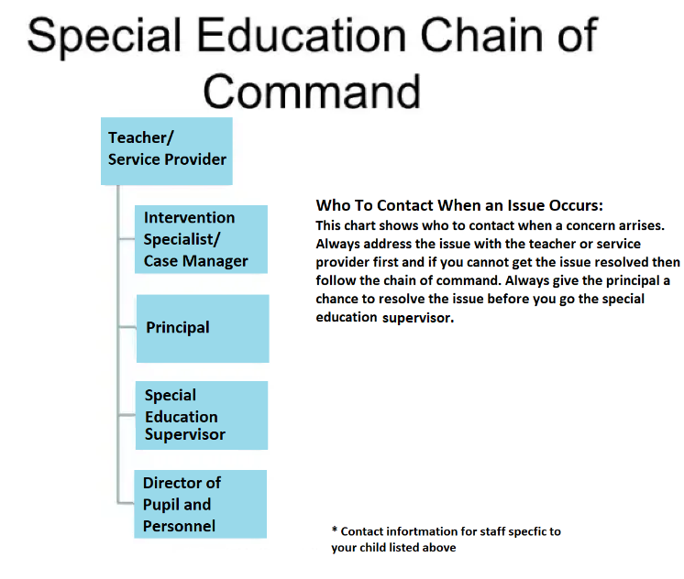

**Medicaid Consent Form (this form will be emailed to you via samegoal or it can printed off and filled out)**

